🚀 POC1

System requirement [deprecated]

FX AI Agent

Predict whether the exchange pair will appreciate / depreciate / no change using relevant economic indicator and fundamental financial analysis

Motivation

If we can correctly predict we can short/long/hold the currency and make a profit on how the currency appreciates or depreciates.

Input

- An exchange pair for example THB/USD
- Let donate the pair as X/Y
- Real world input (Klod)
  - Economic data(Slow)

  - Price Movement
    - Resistant and support level
    - How fast is it moving?(momentum)
  - News
    - What are people saying, Trump?
    - What news is moving the market?
      - New Fed chair
      - What do other central banks say?
  - Correlated Asset
    - USDTHB in particular move with gold
    - DXY- the dollar index (weighted average of other currency with USD, EUR and JPY have the most weight in the bucket)
    - What are other similar currencies doing?
Currency pairs such as JPYTHB, SGDTHB and CNHTHB usually travel in the same direction. This eventually resulted in USDTHB moving in the same direction with USDJPY, USDSGD and USDCNH.
Output

- Whether X appreciate / depreciate / no change against Y in the following day/week/month
- If the confidence is low the agent will output the result as no change
- The LLM should give a brief reason why it make a particular reason

Solution

We will implement a LLM Agent using LangGraph that will perform the prediction based on public/private data. Initially we will make the agent specialize where X is THB only and Y can be any other currency. For the first version we will focus on Y being USD first.
In the next version we plan to scale to do multiple concurrent predictions on THB against multiple currencies.

LLM relies a lot on properly formatted and accurate context. We will implement several MCP to make sure the agent gets the most accurate real time information to make its own decision. Since LLM is not designed to do Math will also include an MCP to analyze ratios and other economic indicators.

Architecture

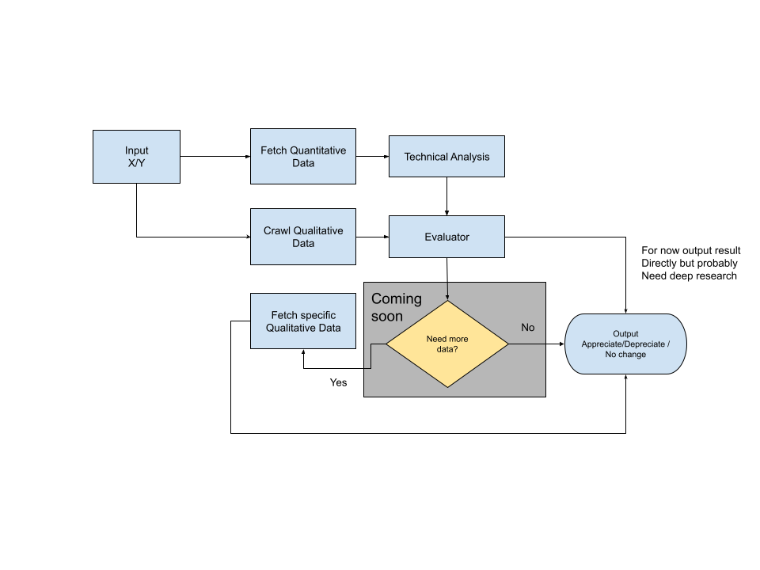

Node Roles / Agent

Fetch Quantitative Data
- Use api from the following sources
  - For Thailand use the following sources
    - https://portal.api.bot.or.th/portal
  - For other major economy use this api
    - https://data.imf.org/en
    - https://fred.stlouisfed.org/
- Fetch data
  - 1 month Interest rate
  - 1 month Exchange rate
  - CPI
  - Export / Import Index
  - And more in the future

Crawl Qualitative data
- Use SerpAPI Google search engine to do a google news search about X and Y
- https://serpapi.com/dashboard
- https://serper.dev/playground
- Store the Top 10 Hit results to the current state
  - We can add more in the future if we want
- The Evaluator can decide whether to do a deeper search on a particular if it wanted

Fetch Qualitative data
- Coming soon will add this node in after the first round of back testing
- Use firecrawl to get markdown of the news
- https://www.firecrawl.dev/
- Use LLM to summarize and save to state for the evaluator to help with its prediction

Technical Analysis
- Convert raw quantitative data to a ratio or single economic indicator
- Support the following economic indicator calculated from current state
  - Inflation rate
  - Interest rate differentials between X and Y
  - SMA
  - Trade balance (Deficit?)
  - Current account balance

Evaluator
- We use an LLM thinking model to make a decision based on the data fetched from all the previous step
- Make a decision whether it need more specific data or it can output the result immediately

Back testing
How to make sure whether this is worth doing?
Firstly, we need to determine a baseline to keep things simple. We will use SMA (Simple Moving Average) to predict the currency. At minimum if our agent cannot beat SMA the agent is not usable we will conclude that the POC as a failure or we might tune the system prompt more before making that final decision.

The score will be based on whether the agent/model/analysis correctly predicts whether the currency appreciates / depreciates or no change in the next month. We do testing from 2023-9-1 to 2025-8-1 with a total of 24 months. The result is represented as total correct / total predictions.

Results

Configuration | Correct ratio (24 months) | Correct ratio (12) months starting at 2024-9-1
SMA | 10/24 | 6/12
EMA | 10/24 | 6/12
Agent - ChatGPT 4o - ex rate | 12/24 | 6/12
Agent - ChatGPT 4o - ex rate + headline only | 13/24 | 9/12
Agent - ChatGPT 4o - ex rate + headline + IMF indicator | 13/24 | 9/12

Analysis

From the result we can make the following conclusion currently

- IMF indicator have no impact to the prediction result
- LLM has the potential to improve the performance. However, the confidence level for all results is mid there is no high or low. We need better indicator for the LLM
- The LLM result suffers from older results because it is relying on very old headlines where the content could be deleted. We can explore using perplexity on fetching better headlines.
- We might need another LLM to help evaluate the headline look like it is having the most impact on the result right now

💙 MLP Beta-v0.1

MLP Beta-v0.1 [deprecated]

Overview

Currently our system consist of 3 agents

- Researcher
  - Find sentiment data from the internet and summarize it in a structure format into the database
- Analyst
  - Predict whether the currency will appreciate or depreciate based on previous rates and data collected by the researcher
- Trader
  - Make trade decision by ensembling the information from researcher and analyst

Why we need to split into 3 agents and not do it in 1 prompt
- From our research we find out each model performs each task with different abilities and pricing points that allow us the flexibility to optimize both price and model performance.
- Context length limit: to do it all in one prompt would require a very long input prompt consisting of multiple calls.
- Debugging: we can track and find out why it makes each decision. Which agent causes us to lose profit etc.
- Scalability: In the future we can spawn multiple analysts and researchers in parallel to help the trade make the best decision. We can already see the trader must be a model that supports a long context limit.

The only problem is that it requires more work but allows multiple people to work on each agent individually. Currently the code does not properly decouple all the agents together properly but we can fix that later.

Researcher

Currently we have only tested it with 2 models Perplexity sonar-pro and Grok 4.1. We found out the performance of Grok 4.1 to be very poor. Most likely because Grok failed to return in the format we wanted. In the future we plan to test research with Gemini 3 and compare it against sonar-pro. There are other parameters we can tune more for sonar-pro such as include and excluded websites. However, we will work on that later.

Analyst
We tested the analyst using multiple kinds of models. The test setup is the following: the analyst needs to predict whether tomorrow the currency will appreciate or depreciate although we include high / medium / low for each we will ignore that and only check whether it correctly predicts the currency value.

These are the results we only include for analysts that use data from sonar-pro as a research agent. Where the target currency pair is THB/USD

model | Predict range | Accuracy
gpt-5.2 | 2025/11/01 - 2025/11/30 | 0.5
gpt-5.2 | 2026/01/01 - 2026/01/30 | 0.87
gemini-3-pro-preview | 2025/11/01 - 2025/11/30 | 0.83
gemini-3-pro-preview | 2026/01/01 - 2026/01/30 | 0.645
gemini-2.5-pro | 2026/01/01 - 2026/01/30 | 0.48
deepseek-v3.2-speciale | 2025/11/01 - 2025/11/30 | 0.38
claude-sonnet-4-5 | 2025/11/01 - 2025/11/30 | 0.33
claude-opus-4-6 | 2025/11/01 - 2025/11/30 | 0.9
claude-opus-4-6 | 2026/01/01 - 2026/01/30 | 0.87
xiaomi/mimo-v2-flash | 2026/01/01 - 2026/01/30 | 0.36

Here we can conclude that claude-opus-4-6 performs the best followed by gemini-3-pro-preview. The only problem is that claude-opus-4-6 is very expensive below is the price comparison between several models that could potentially be our analyst

Metric | claude-opus-4-6 | gemini-3-pro-preview | gpt-5.2
Input per M tokens | $5 | $2 | $1.75
Output per M tokens | $25 | $12 | $14

If we look at price to performance we should go with gemini-3-pro-preview as our analyst. As new models get released quite often we can easily re-run this benchmark and update our model with the best performing one. Especially ones that are cheaper.

Trader
Currently our trader is not very realistic because it is using data from BOT (Bank of Thailand) however in a naive trading environment we expect the agent to easily make a profit. The trader will use the data from sonar-pro researcher and claude-opus-4-6 analyst. They will trade in a 1 month period. We are looking for the max gain from initial investment. The trade is given 1 million baht to invest the score is max of initial investment subtract current balance. I will create an interactive graph that shows the agent's decision when it decides to buy or sell. Below is the summary of the result. During testing some larger models fail to run either hitting rate limit error or it is too slow. The model that fails the run is excluded from the result. The trader is run from 2026-01-01 to 2026-02-02 and called every single day.

model | Max gain | Remark
gpt-5.2 | -1,933.09
gemini-3-flash-preview | 1,336.10
deepseek-chat (v3.2) | -7,156.25 | Need to decrease lookback day due to context length limit
xiaomi/mimo-v2-flash | -2,100 | Fail to understand sell condition not enough balance

From the result we should stick with gemini-3-flash-preview as our trader. I believe we can improve the performance by improving the prompts and our data sources for the researcher. I tried running with the pro but got into a lot of rate limits. This is the same situation for Claude also.

In the next phase we plan to change the trader to trade on Bitkub data. However we need to add a mechanism to not call the LLM too often because it is expensive. One plan is to add a change threshold if the price changes beyond the threshold it will trigger the trade agent. However, we will automatically trigger the agent everyday at least once in the morning to make some strategic decisions.

Conclusion
From our initial findings we now have a good foundation for testing different models and prompt strategy. We are ready to move on to the next phase. I think we should go with this architecture. We will prioritize the following features for the next phase.

- Backtrading on Bitkub data
- Backtesting trigger on previous news data to simulate real time news trigger
- Trade visualization from back trading
  - This will allow klod01021@gmail.com to analyze the model decision and use that to tune the prompt

Other backlogs

- Real time paper trading on Bitkub or FSB I am targeting this on the beginning of March
  - We will leave this on either on a home server aka Ham’s House or Cloud VPS server
- Agent prompt and parameter tuning

💡 Improving prediction

Improving prediction

While writing a naive trader we discover that predicting whether next day rate value does not give us that much leverage. This is because the change between days can be very minimal in the range of less than 0.2%. For example if you invest 1 million baht you will most likely gain or lose 200 baht which is nearly nothing. This is actually less than the interest rate but the interest rate is worse because it is like 0.6% per year. This is at most per day. But if you predict at a 50% rate you will not lose or gain it will be in equilibrium. However, if we compare the rate change weekly we are more likely to gain more. The change is still small though.

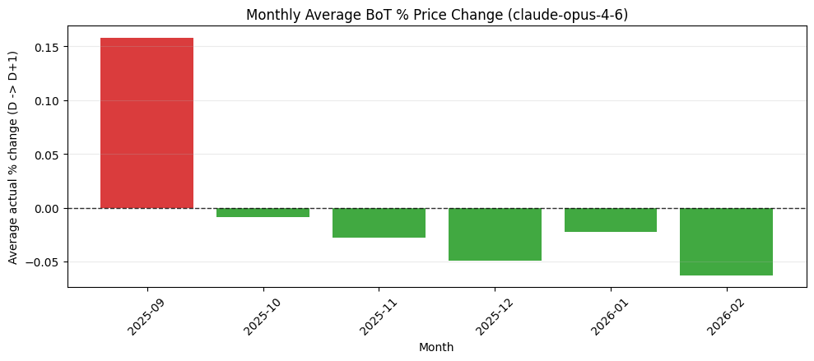
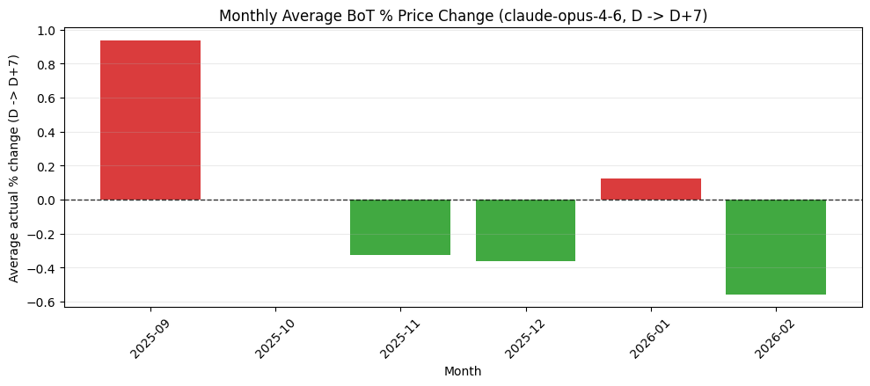

Therefore, in the graph below we determine whether or not the prediction is correct or not within a 1 week span. From the date of prediction rate vs all the rate in the future within 1 week. It must increase if the currency depreciates or decrease if the currency appreciates by a certain percentage against base rate following these thresholds.

- High - >= 1%
- Medium - >= 0.5%
- Low - >= 0.25%

We can see the maximum correctness we were able to achieve is in December with a correctness of 74% the worst month is October with correctness of 33%. On average we are around 50% correct. This is equal to not gaining or losing money. We will not be able to pay for the cost and doing all of this is a bit worthless.

Ignore 2026-02 the data is not complete yet
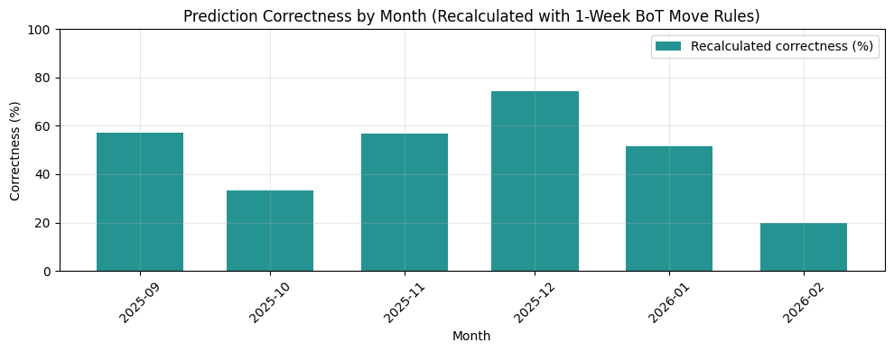
In the graph below we expect the green dot to be at the bottom and red dot to be at the top. You can see we over predict appreciation. Luckily this is quite accurate compared to the graph directly below. We manage to correctly predict the trend however our timing and our rate is a bit wrong. 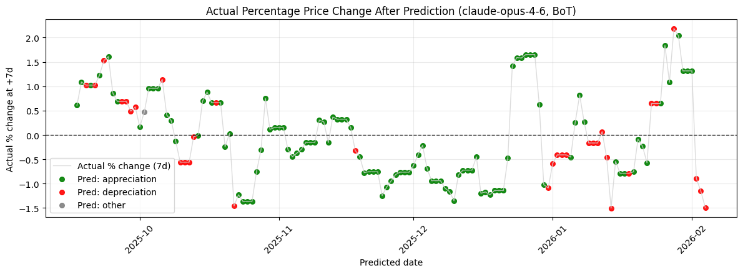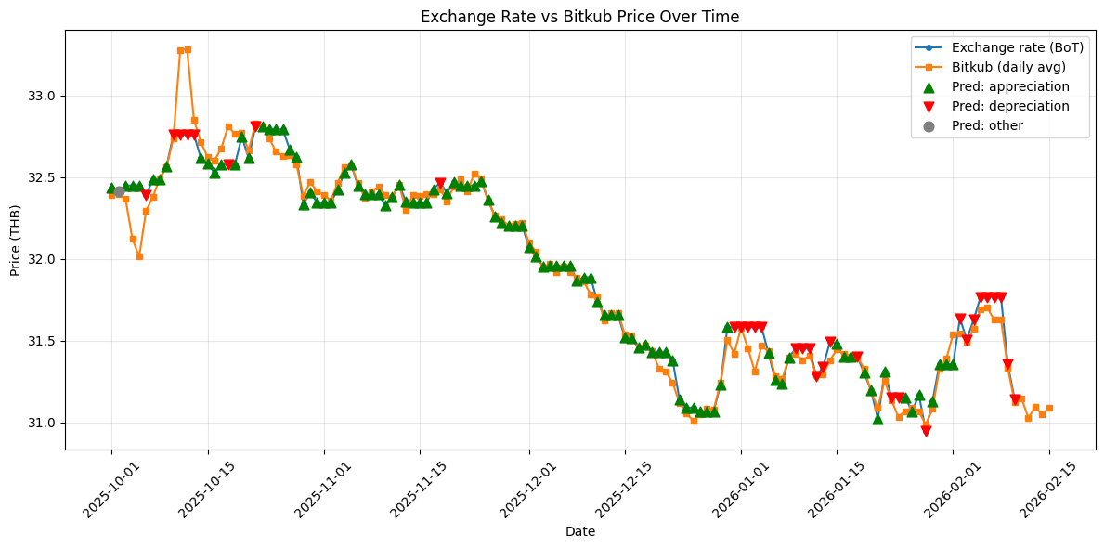

We investigated further and found that from the citation the website used is some random website that analyzes exchange rate such as

- www.exchangerates.org.uk
- https://www.businesstoday.com.my
- https://www.banque-france.fr
- https://www.keycurrency.co.uk
- https://www.danamon.co.id

These are sources that I never heard of before. I am not so sure it is reliable or not therefore one major change is we are going to use a more reputable site as the source. We also included some Thai local news sources. These websites are quite good at analyzing data and reliable to a certain extent. Furthermore we make sure the analyst learns from past predictions also of up to 15 days.

We switch to gemini-3-flash-preview as a researcher the sentiment analysis look a lot more reasonable this is the new result

The threshold we use here is where the threshold is how much the rate changes from the base rate it was predicted from. These thresholds are determined from analyzing the data.

High - 0.5%
Medium - 0.25%
Low - 0.1%

Correctness is determined by the same rule at the top however we also include the graph where instead of 1 week it is based on a 2 week window instead also.

Gemini pro 3 preview predictor

Without checking whether high/medium/low was right or not we achieve more than 60% accuracy for every month. However, if we check for the threshold November performs pretty poorly. However we achieve more than 50% for any other month. We can rule this as an outlier maybe.

In a 2 week window we can see our prediction improve by 10% from all months except November where no threshold improves but with threshold is a complete disaster. Overall we are gaining more than losing I hope.

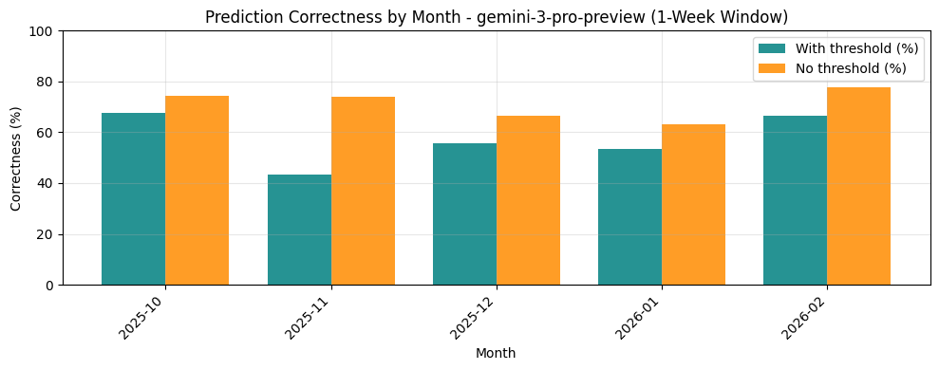
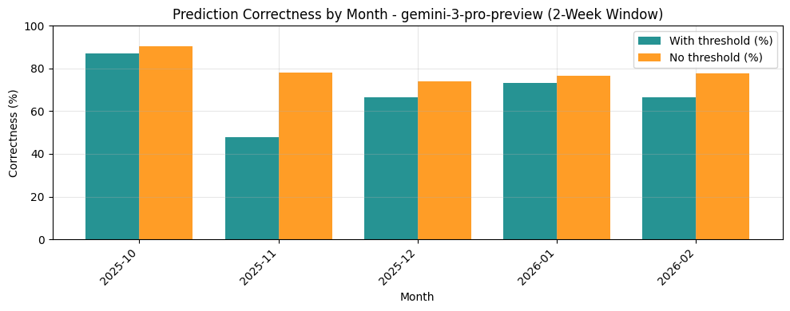

GLM 5

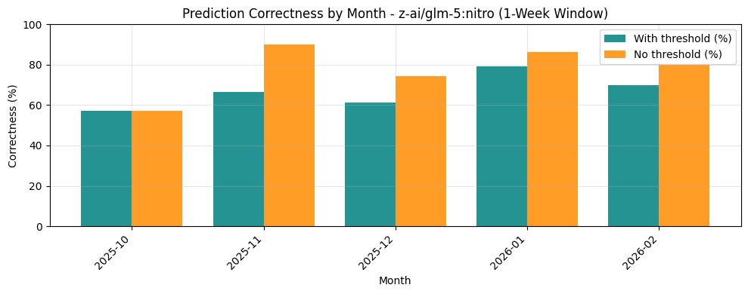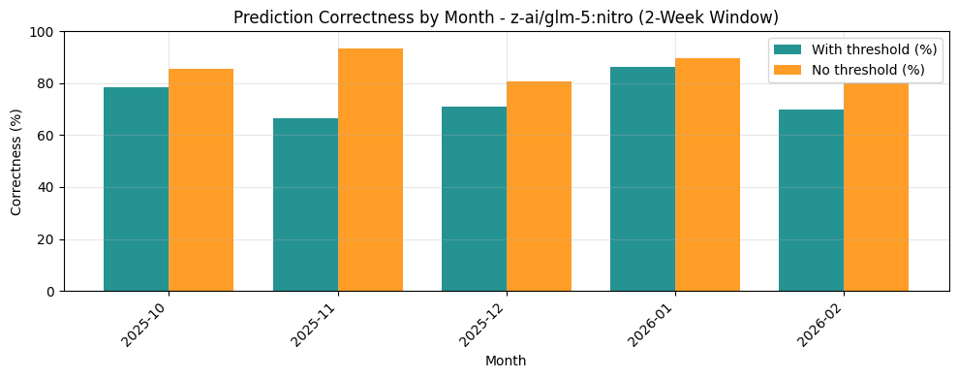

Kimi K2.5
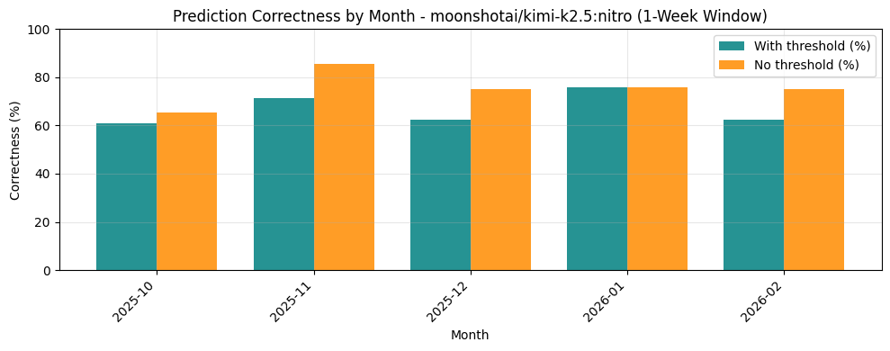
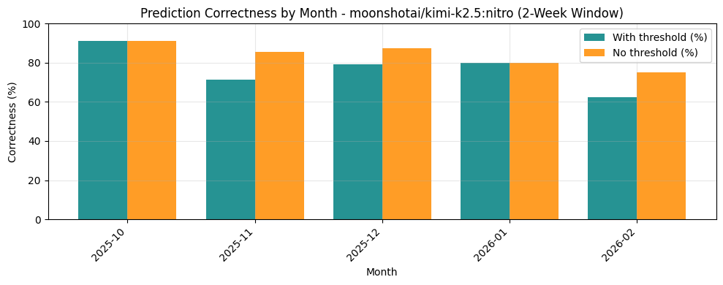

Price change over 4 months period from October to around Mid of February histogram

Day by Day Price Change Percentage

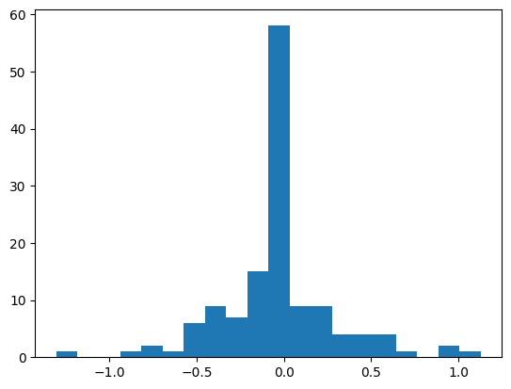

D+3 Price Change Percentage

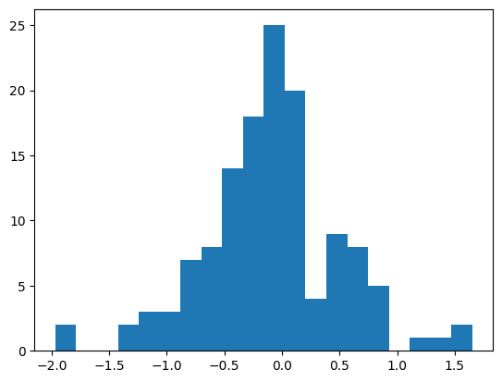

D+7 Price Change Percentage

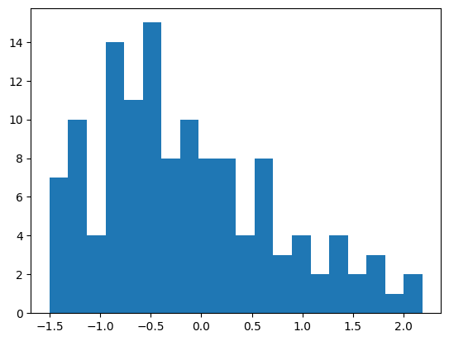

💱 Trader implementation

Trader implementation

We attempted to build 2 types of trader. One where the decision is based solely on the LLM another where it is rule based.

LLM implementation
I attempted many prompt engineering to improve the result however, each model behaved very differently. For example, gemini-flash keeps investing in small chunks. While other models like Kimi K2.5 or GLM5 might invest it all in one go. This is very experimental indeed and uses a lot of token. The biggest problem is speed. If you need to take a very long time to make a decision the rate or price point can easily be lost at that moment already. All models perform horribly this is most likely because the prediction is wrong or the day to day rate difference is very negligible to actually make a profit you can read this up in Improving prediction.

Naive Rule Based
I have used LLM to summarize this for me from source code.

Overview
The naive strategy (use_naive_strategy=True) is a rule-based trading logic that uses analyst predictions (predictor output) and fixed thresholds instead of LLM trade decisions. It does not use SMA/EMA/RSI or other technical indicators.

Prediction Types
Predictions come from the analyst (PredictorResultModel) and use PredictionType:
- Direction: appreciation, depreciation, or not_confident
- Strength: high_, medium_, or low_ (affects position size and thresholds)

Threshold Parameters
Parameter | Default | Role
naive_high_pct | 2.5% | Min price move % to act on high-confidence predictions
naive_low_pct | 1.0% | Min price move % to act on low-confidence predictions
naive_high_conf | 50.0 | Share of balance/position used when confidence is high
naive_low_conf | 25.0 | Share of balance/position used when confidence is low
For medium, thresholds and size are averages of high and low.

Algorithm Flow (v0.1)

1. Extract prediction and market data
- Prediction string (e.g. high_appreciation, low_depreciation)
- Price: last row of 1‑min Bitkub rows, else latest_close, else last of current_rates
- last_tx_rate: rate from most recent trade for that currency
- held: current units
- max_buy_units: capped by balance and volume

2. Handle not_confident
- If "not_confident" in prediction → hold.

3. Map confidence to size and price thresholds
- high_: buy_pct = naive_high_conf/100, price_pct_threshold = naive_high_pct
- low_: buy_pct = naive_low_conf/100, price_pct_threshold = naive_low_pct
- medium: average of high and low.

4. Appreciation (predicted up)
- If held <= 0 → hold (nothing to sell).
- If last_tx_rate exists: rise_pct = (rate - last_tx_rate) / last_tx_rate * 100
- If rise_pct < price_pct_threshold → hold (“rally below threshold, wait”).
- Otherwise: sell buy_pct of position (held * buy_pct units).

5. Depreciation (predicted down)
- If neither appreciation nor depreciation → hold (“no clear direction”).
- If last_tx_rate exists: drop_pct = (last_tx_rate - rate) / last_tx_rate * 100
- If drop_pct < price_pct_threshold → hold (“dip below threshold, wait”).
- Otherwise: buy with buy_pct of balance (spend_thb = current_balance * buy_pct), capped by:
- max_buy_units
- current_balance / rate
- If resulting units <= 0 → hold (“insufficient balance”).

Intuition
- Appreciation: sell only if the move up is at least price_pct_threshold since last trade, and sell a fraction of the position defined by buy_pct.
- Depreciation: buy only if the move down is at least price_pct_threshold since last trade, and spend a fraction of balance defined by buy_pct.
- Confidence: high predictions use larger sizes and higher price thresholds; low predictions use smaller sizes and lower thresholds.

Result
The analysis is omitted due to how badly this perform not worth analyzing as we quickly resolve the bad performance with the new approach below.

New Rule Based Approach ideation (v0.2)

From the result in Improving predictions we know that when we predict something we cannot be sure when that appreciation or depreciation will happen. But we know with at least 60% certainty that in 1 week that prediction will be realized. I think it is very important for us to tune the predictor to give the most accurate result as much as possible. Therefore I propose a new algorithm based on this predictor and our analysis.

Algorithm

1. Entry Strategy
- Condition: Open a position only when the model predicts the currency will depreciate.
- Frequency: Decisions are made daily at midnight (Thai time). You can only open one new slot per day.

2. Exit Strategy (Taking Profit)
- Target: Sell once the currency hits your predicted depreciation threshold (e.g., a specific percentage drop).
- Execution: You will only sell during "appreciating slots" (upward price movements).
- Batching: All units within a single slot must be sold at once. If you hold 4 positions, you need 4 available slots to exit them all.

3. Risk Management (Stop Loss)
- The "2x Rule": If the currency moves in the opposite direction (appreciates) by more than twice your target threshold, exit the position immediately to cut losses.
- Duration: There is no time limit; you hold the position indefinitely until either the profit target or the stop-loss is triggered.

Key Rules at a Glance
Rule | Requirement
Buy Timing | Once per day (at midnight Thai time).
Sell Timing | Anytime, provided the threshold is met and an "appreciating block" is open.
Capacity | One slot = one buy. Must have an equal number of open exit slots to sell.
Priority | Profitability over greed; exit as soon as the math works.

Problems
Currently our predictor threshold is not very accurate therefore it is questionable whether we should rely on that or not. Or we did not find the right number yet. We should not reinvest all the money back because it is very hard to determine our actual profit gain. Furthermore, lack of investment makes it misses a lot of potential opportunities also.

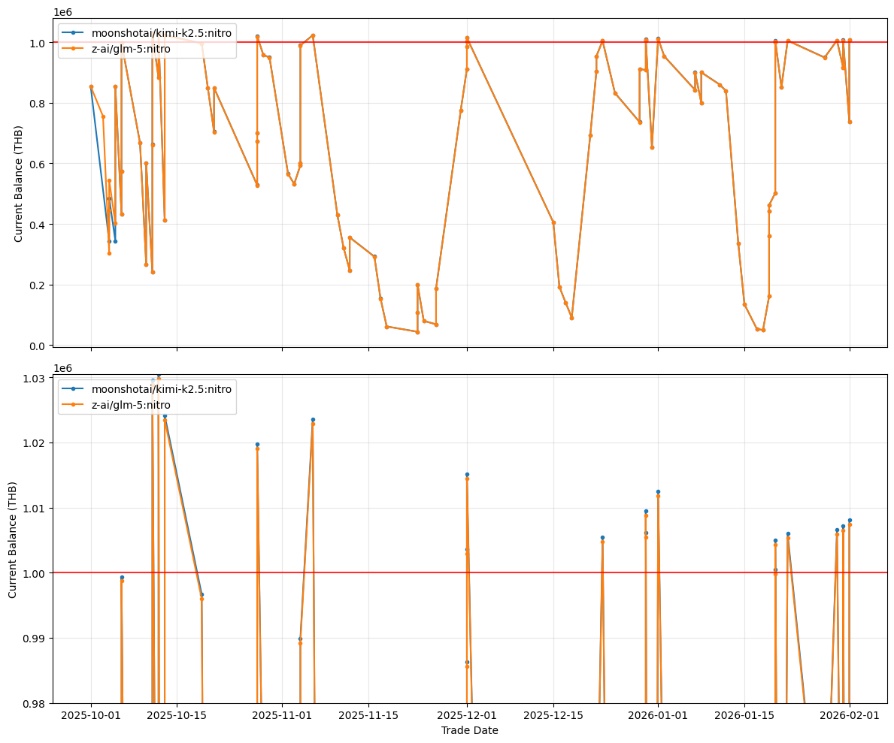

Result from slot base approach we should aim to beat this the maximum profit gain is around 30k but you can see in the next month we never reach the same gain as last month if we do not reinvest it all back we could have gained a fixed 30k in that match at around October. Assuming we get an average of 15k per month this is around 1.5% gain per month. Our aim for back testing at least should be around 5%-10% gain per month and around 2.5% - 5% gain per month for paper trade.

🎬 Phase 3.5 Action plan

Phase 3.5 Action plan

- Worapol Boontanonda (Hamuel) finish refactor the code and support full parameter adjustment include the date range
- Worapol Boontanonda (Hamuel)Create a new UI to create new scenario that support different parameters to adjust
  - K
  - Gradient
  - Time range (this is controllable by AI only right now if trader override this it will use this value instead NOT the AI)
  - Worapol Boontanonda (Hamuel)talk with klod01021@gmail.comto explain each parameter
- klod01021@gmail.com buy mac mini and send it to Klod house
  - Worapol Boontanonda (Hamuel)create new account for everything and connect with klod01021@gmail.comthrow away credit card
- klod01021@gmail.comtalk to SCBS aka InnovestX about connecting to API
- klod euchukanonchaiwill discuss more with InnovestX on api stuff
- klod01021@gmail.com teach Worapol Boontanonda (Hamuel) futures 🙂
- Redesign trader and split into 3 components (v0.4 aka Phase 4)
  - Trader focusing on technical analysis with different strategy
  - Risk management focusing on not making us go broke
  - Executor for executing the trade via TradingView or Bitkub or whatever
- Worapol Boontanonda (Hamuel) need to open an account on InnovestX do this after implementing executor
- Worapol Boontanonda (Hamuel)develop new service connector to settrade https://developer.settrade.com/open-api

Main timeline

- April - start sandbox trading with settrade and play around with InnovestX trading view
- May/June - start real trading with limited contract aka this is Phase 4
- Keep improving - the algorithm to maximize profit here we are going to move to iteration 2

🔮 Future and TFEX

Future and TFEX
- Futures are contracts you make on a particular asset
- In TFEX THB/USD contracts are split into months, however we should only trade on contract with these codes H, M, U and Z. Because other contracts have limited liquidity and the price jump a lot that will break the algorithmic trading strategy we wrote
- Each code above is associated by the fiscal year Q1, Q2, Q3, Q4 respectively.
- The price of contract is not the same as spot price because the price is spot price + fx swap (basically calculated by the ratio of the interest rate of 2 countries)
  - For a simple algorithm we can ignore fx swap and just focus on the spot price but we need to keep this in mind.
- Each contract has an expiry date. You must close the contract at least 1 day before the expiry date because the price will fluctuate a lot on the closing date.
- When we buy a contract we need to pay the following https://www.tfex.co.th/th/products/currency/usd-thb-futures/margin
  - Initial margin - need to pay when we open the contract
  - Maintenance margin - need to pay to keep the contract open if you do not pay this fee on time the contract is immediately closed
    - Fixed Margin Threshold: You must maintain a minimum equity balance of 492 THB (Maintenance Margin); if your balance falls below this, you must deposit enough to return to the full 700 THB (Initial Margin).
    - Variable Profit/Loss Calculation: Every "tick" or "last digit" change of 0.01 THB in the exchange rate results in a 10 THB gain or loss in your equity ($ΔEquity = ΔPrice ×1000$).
    - More detail here: https://media.tfex.co.th/tfex/Documents/2024/Oct/TFEX_All_Currency_Futures_Contract_Specification.pdf
- Each contract is equal to 1000 USD each rate change is exemplified take note of that part. This is why the maintenance can get very high if we attempt to keep the contract open when the price changes a lot against our predicted position.
- When you open a contract you have the following choices
  - Open long
  - Open short (the above example is flip for short)
- When you close a contract you have the following choices
  - Close long
  - Close short
- Quick math for long and short where 0 is current price and 1 is the price of next tick
  - Long - ${ΔPrice =P}_{1}-P_{0}$
  - Short - ${ΔPrice=P}_{0}-P_{1}$
- In Forex the trading is done 24/7 However, for TFEX only trade on the following hours and not on national holiday announced by Bank of Thailand
 | Pre-open | Trading hours
Morning | 09:15 - 09:45 hrs. | 09:45 - 12:30 hrs.
Afternoon | 13:15 - 13:45 hrs. | 13:45 - 16:55 hrs.
Night | 18:45 - 18:50 hrs. | 18:50 - 03:00 hrs. (T+1)

💱 Redesigning the trader

Redesigning the trader
Currently the trader is one big component however it is not flexible enough to run different trading algorithms and no reliable stop loss mechanism.

We will decompose the trader into 3 components

- TA - Technical Analysis
  - This contain multiple trading algorithms
  - It will calculate with math or machine learning (well ML is math anyway lol) whether we should take a new position at this price or not and what position we should take
  - TA will output the position and price.
  - Where o is the opening price and l is stop loss limit
  - Examples
    - Long (buy) @ price o and limit at price l
    - Short (sell) @ price o and limit at price l
  - Recompute every price change and new predictions
  - Must be associated with price and prediction row
- SL - Stop loss
  - Check all current position open there will be 2 layers to the system
  - Layer 1 - Limit loss output by TA if reach limit loss close the contract immediately at a loss and send notification with L1 message.
  - Layer 2 - Max threshold loss if any if the open position exceeds this loss hard limit despite what the TA output closes immediately and sends notification with L2 message. (emergency stop do not open any new trade)
  - Layer 3 - Sum stop loss if all of the contract loss reaches a specified value send notification for manual intervention.
  - Trigger every price change if the process fails or throw an exception must send notification immediately.
- Executor - do the trade depending on that exchange rules we will implement for settrade sandbox, InnovestX (TradingView) in the future Bitkub.
  - Record new open position (contract) into the db for SL
  - Check TA whether the current price can be executed or not
  - Trigger every new price change only or when the market opens / before the market closes.
  - For the trade to be executed it will follow the broker/exchange rules also
    - For example
      - can place new order within specified time only
      - Can settle or close contract within new specified time only
      - Need to force sell before contract expired aka Close the position
      - Need to analyze bid and offer prices for the most optimum Open price
  - Must be associated with TA role

Trading Strategy

Trading Strategy

Inputs

- Prices - for asset pair
- Analyst predict high/medium/low appreciation/depreciation
- Time range - how long this position/prediction last for
- Other input are constants

Current strategy
- Our current strategy is Bollinger Breakout
- Klod will list some more classic available strategy

ML
- https://github.com/AI4Finance-Foundation/FinRL
  - https://arxiv.org/pdf/2501.10709
    - This paper uses the ensemble method
    - The result is ok however it is tested on US Stockmarket old data only
    - PPO look the best however make a lot of risky decision
    - DPQ is best suited for crypto market
    - Ensemble help diversify the risk in making the decision
    - We need to train it on our data before using

Simple Stategie

1. Simple Oscillator Strategy
Trade only in the direction of the AI’s forecast.
For example, if the AI signals a bullish outlook, we initiate long positions only when price retraces to the lower bound of the trading range, such as -1 standard deviation from the current mean price.
We then exit when either:
- The target price is reached, or
- Price reverts back toward the midpoint to +1 standard deviation of the established range.

2. Enhanced Oscillator Strategy (with RSI Confirmation)
We can improve the basic oscillator model by incorporating momentum indicators such as Relative Strength Index (RSI) to confirm entry and exit timing.
For example:
- AI indicates a buy signal
- RSI is at the lower end (e.g. RSI = 20), suggesting oversold conditions
In this case, we gradually build a long position in smaller increments.
We then scale out or take profit when RSI reaches elevated levels (e.g. RSI = 80), indicating overbought conditions.
This helps align AI directional bias with market momentum extremes.

3. Range Trading Strategy
The trading bot should be capable of identifying and operating within its own market range.
This can be established using previous swing highs and lows. Once the range is defined, we create tolerance bands around these levels.
Example:
- AI expects price to rise
- Bot buys near the lower boundary of the range
- Bot exits or sells near the upper boundary of the range
This strategy can also function without AI input, particularly in highly compressed or sideways markets where mean reversion dominates.
If price breaks outside the range, the bot should either:
- Cut losses, or
- Lock in profits depending on positioning.
Mean reversal trading

4. Breakout Strategy
When the market begins trending strongly in one direction and the AI correctly identifies the move, the system should be willing to participate rather than rely solely on range trading.(buy only on pull back)
For example:
- Price breaks above an established range
- AI maintains bullish conviction
The bot should enter long positions to capture momentum continuation.
Risk management rule:
- Exit if price falls back into the prior range
- Or if momentum weakens materially
This ensures the strategy can capture directional trends while avoiding false breakouts.

5. Volatility Compression Accumulation Strategy
When market volatility contracts and price begins trading in a tighter range, the system should gradually accumulate positions in the direction of the AI forecast in anticipation of a future expansion move.
For example:
- AI signals a bullish outlook
- Price volatility declines significantly (narrow daily range, lower Average True Range, tighter bands)
- Market trades sideways in a compressed range
In this case, the bot slowly builds a long position in small increments while price remains stable and contained.

Entry Logic:
- Buy partial size near the lower half of the compressed range
- Continue accumulating while volatility remains subdued
- Maintain directional bias only in line with AI signal

Exit Logic:
- Reduce or close positions when volatility expands sharply in profit direction
- Take profit on breakout move or at predefined targets
- Exit if price breaks against the AI view or compression fails downward

TODO

TODO Phase 4+

High priority
- Don’t use closing price use live price for technical analysis
- Graph change to candlebar for correct technical analysis
- Klod want notification on new prediction
  - trigger/researcher/analyst
- Changing from email to discord I will create new discord server for rising whale
- Fetch BOT api for financial day holidays to stop the TFEX order

Low priority
- Implement all the 5 basic strategies fix current one to correspond to those name
  - Probably finish 1/2/3/4
- Put executor decision on tfex graph

Executor logic

Executor logic

SettradeDerivativesExecutor (TFEX)
Sessions & opens (TA limit opens / amendments)
- Must be inside effective Bangkok TFEX windows (trimmed open/close — ~09:46–12:29, 13:46–16:54, 18:51–02:59).
- Last ~5 minutes of each segment: no new TA opens (is_tfex_near_session_end_no_new_opens).
- Closes in that buffer: only stop-loss may close; other TA closes are rejected.
Sizing
- desired_contracts = round(invest_pct × tfex_max_open_contracts), at least 1 if opening.
- Volume clamped to remaining room vs tfex_max_open_contracts and signed position (long vs short).
Broker truth
- Prefer get_portfolios() net over DB when the SDK is live; logs drift vs session._get_current_units.
O001 / “flip”
- If request is long but net short (or short but net long): on real / UAT+SDK, close_position first (full opposite), then re-check TFEX open preflight on wall-clock Bangkok, refresh symbol/net, then open.
- Sandbox dry-run cannot flip → preflight error unless SETTRADE_SANDBOX_USE_SDK=1.
Working orders
- Open blocked if a tfex_working_order close leg is still working (real tier).
- Orphan broker opens: if get_orders() shows working opens that don’t match the single tracked local open → skip (transient; ok=True, 0 units).
- Close: if broker already flat → success, no duplicate. If broker shows working close → skip (wait), not a hard failure event.
Market / holiday
- market_status from InfoV3 (same feed as prices) can block opens/closes when the exchange is closed.
GWD-01 / 0.01 tick
- Limit prices quantized to 2dp. If limit and cached last are the same tick, executor may nudge one tick in the aggressive direction (buy +0.01, sell −0.01). If still invalid → skip open/close (no order).
Aggregate allocation
- tfex_aggregate_allocation_check_ok before real place_order — live-paper TFEX budgets vs equity.
Limit lifecycle (real tier)
- change_order to increase volume only if same symbol and stored Settrade side matches the request; opposite side → fail fast.
- After submit: MQTT wait for full match, capped by ~1 hour, 15 minutes before segment effective end, and optional SETTRADE_LIMIT_FILL_TIMEOUT_SEC; optional SETTRADE_LIMIT_MOVE_CANCEL_PCT drift cancel; SETTRADE_LIMIT_FILL_IGNORE_SEGMENT_END relaxes segment shortening.
- Sandbox: default no place_order (notifications only); SETTRADE_SANDBOX_USE_SDK=1 sends UAT orders; no blocking full-fill wait in sandbox.
Stop-loss closes
- Use MP-MKT (derivatives channel) per module doc; session-end rules still gate non-SL closes.
Closes (TA)
- Must be in TFEX trading window (same effective hours).
- Limit closes get same tick / nudge logic as opens where applicable.
Notifications / audit
- SNS + broker_order_event on real outcomes; some preflight “skip” paths don’t persist events.

Phase 4 Summary

Phase 4 Summary
Integration branch 0.4 brings together live/paper trading reliability work, fuller TFEX (Settrade) execution and portfolio/order handling, dashboard and prediction UX, Discord notifications, and data/timezone consistency fixes. This draft is intended for consolidated review before merging to main.

Highlights

Live trading & sessions
- Refactor toward TradingSession-centric flows: executor-based routing, clearer trade execution wiring, and more event-driven evaluation paths (fewer brittle periodic timers where replaced).
- Redis concurrency patterns (e.g. non-blocking pipeline mutex keyed by session, predictor pair locks / skip-when-busy) to reduce races under load.

TFEX / Settrade
- Portfolio and working orders: treat broker state as truth (e.g. get_portfolios net, working-order reconciliation, duplicate-close and terminal-order guards, MQTT/working-order recovery paths).
- Execution quality: quantized limit prices for segment rules (e.g. GWD-01), aggression/buffer tweaks for TA orders, symmetric mean-band handling, tier/regime-aware band logic where introduced.
- Market context: MQTT lifecycle (incl. reconnect around session boundaries), Bangkok-schedule alignment for holidays and predictor windows, SNS copy for fills and non–stop-loss flows.
- Realized P&L / accounting: scaling and labeling improvements for THB and dashboard-facing numbers.

Predictions & research
- Reasoning summaries and stricter scheduling (e.g. daily window / explicit triggers).
- Confidence and horizon handling: executor/TA skips for low-confidence paths, overlays and prompts tied to time_range_hours, clearer “skip”/not_confident visualization on charts.
- Research → prediction sequencing and richer Discord intel (window, headlines, optional per-row sentiment).

Dashboard & market data
- Bangkok-centric timestamps and labels across tables, TA bands, and feeds; UTC-naïve parsing fixes that removed multi-hour drift in places.
- Market feed: OHLC candle bucketing/storage, candlestick visualization, tooltip/hover and axis alignment fixes, optional confidence filters on prediction overlays.
- TFEX tooling: dedicated open-order views and reconcile/backfill helpers; live-paper trade_config editing via PATCH; regime/tier surfaced on TA-band views where implemented.

Data & migrations
- Database timestamps: standardize persistence as naive UTC where changed, with coordinated UI/API normalization to Bangkok for display—includes Alembic work and merging migration heads where needed.

CI
- GitHub Actions lint workflow removed for now; can be restored in a follow-up.

Review notes
- Large diff (~30k LOC added across many commits); consider focusing review on domains you own first (broker/TFEX, live loop, dashboard API, Discord).
- After merge, run migrations in deployment order and sanity-check alembic heads on the target DB.

